INTERNSHIP COMPLETION REPORT
Infosys Springboard Virtual Internship 6.0
Team Details

Batch Number: 13
Start Date: 02 Feb 2026
Internship Duration: 8 Weeks
Intern Names: Krishni Bansal
Charanya
Revati

1. Project Title
Enterprise Data Cleaning & ETL Orchestration Framework using Python - Group 1

2. Project Objective
The primary objective of this project is to design and implement a fully automated, production-grade ETL (Extract, Transform, Load) data pipeline for cryptocurrency market data. The framework leverages Apache Airflow for workflow orchestration and follows the Medallion Architecture (Bronze, Silver, Gold layers) to progressively refine raw Bitcoin OHLCV data into analytical insights. The pipeline ingests data from two sources — a 10-year historical Bitstamp Kaggle dataset and live minute-by-minute CoinGecko API feeds — transforms the data using idempotent processing techniques in Python/pandas, and loads it into a structured PostgreSQL data warehouse. A Streamlit dashboard provides real-time visualization of market trends and historical convergence, enabling data-driven decision-making for cryptocurrency market analysis.

3. Project Description in Detail
The Crypto ETL Framework is a comprehensive, end-to-end data engineering application built using Apache Airflow (orchestrated via Astro CLI), Python, PostgreSQL, and Streamlit. The system is organized into four integrated modules developed over an 8-week period.

Module 1 — Environment Setup & Pipeline Design (Weeks 1–2): The foundational infrastructure was configured, including the installation and setup of Apache Airflow using the Astro CLI with Docker-based deployment. The Medallion Architecture data model was designed, and the PostgreSQL schema was initialized using schema_setup.sql. Historical Bitcoin OHLCV data from the Bitstamp Kaggle dataset (2012–2021) was prepared for ingestion. Extraction scripts for both historical CSV data and the live CoinGecko REST API were developed and validated.

Module 2 — Data Cleaning & Transformation (Weeks 3–4): The data preparation workflows were implemented in transformer.py using Python and pandas. Raw Unix timestamps were converted to readable datetime formats, null prices were handled via forward-fill (ffill()) to account for low-volume trading gaps, and a Delete-before-Append idempotency strategy was implemented to ensure safe pipeline re-runs. Silver layer aggregation was built using SQL UPSERT (ON CONFLICT) to compute daily High/Low/Average prices from raw tick data.

Module 3 — Orchestration & Monitoring (Weeks 5–6): The Airflow DAG (bitcoin_etl_dag.py) was configured with a Midnight (00:00) cron schedule to process daily market data partitions. A dual-layer alerting system was implemented: real-time Slack notifications via JSON webhook payloads for task failures, and a local fallback logging mechanism writing to error_alerts.txt when Slack is unreachable. Gold layer dynamic views were created to calculate 7-day rolling averages and volatility indices for advanced analytics.

Module 4 — Dashboard & Deployment (Weeks 7–8): An interactive Streamlit dashboard (dashboard.py) was developed to visualize both current market state and historical Bitcoin price convergence. The complete framework was tested on production-scale datasets covering 10 years of historical data merged with live 2026 market feeds. The deployment was finalized using the Astro CLI with Docker, and comprehensive project documentation was prepared covering architecture, setup instructions, and API configuration.

The technology stack includes Python, Apache Airflow (Astro CLI), PostgreSQL, pandas, SQLAlchemy, CoinGecko REST API, Streamlit, Slack Webhooks, and Docker. The project demonstrates real-world data engineering practices applicable to financial analytics and cryptocurrency market intelligence.

4. Timeline Overview

Week | Activities Planned | Activities Completed
Week 1 | Project kickoff; install Airflow via Astro CLI; design Medallion Architecture data model; set up development environment | Environment configured; Astro CLI with Docker operational; PostgreSQL schema designed
Week 2 | Develop historical CSV extraction scripts; configure CoinGecko live API integration; validate data sources | Bitstamp CSV ingestion pipeline working; CoinGecko API extraction script (live_api.py) completed
Week 3 | Implement data cleaning rules in transformer.py; build Bronze layer processing with timestamp conversion and null handling | Bronze layer cleaning complete; Unix timestamp conversion and ffill() null handling implemented
Week 4 | Implement idempotent Delete-before-Append strategy; build Silver layer daily aggregation with SQL UPSERT | Idempotent pipeline complete; Silver layer UPSERT aggregation tested and validated
Week 5 | Configure Airflow DAG scheduling (cron); implement Gold layer analytics views; set up Slack alerting webhook | DAG scheduled at Midnight (00:00); Gold layer rolling average and volatility views created
Week 6 | Implement local fallback error logging; integrate dual-layer alerting; validate full pipeline end-to-end | Dual alerting (Slack + local file) operational; end-to-end pipeline validated on full dataset
Week 7 | Build Streamlit dashboard for market trends and historical convergence; test on production-scale data | Streamlit dashboard complete with trend and convergence visualizations; production-scale testing done
Week 8 | Final deployment via Astro CLI/Docker; prepare documentation; project submission and presentation | Framework deployed; documentation completed; project submitted and presented

5a. Key Milestones

Milestone | Description | Date Achieved
Project Kickoff & Environment Setup | Project scope finalized; Airflow installed via Astro CLI; Docker environment configured; PostgreSQL schema initialized | 02 Feb 2026
Prototype / First Draft | Working Bronze layer pipeline with historical CSV ingestion and CoinGecko live API extraction operational | End of Week 2
Mid-Term Review | Data cleaning, transformation, and idempotent Silver layer aggregation complete; pipeline reviewed and validated | End of Week 4
Orchestration & Monitoring Complete | Airflow DAG scheduled; Gold analytics views created; dual-layer Slack and local alerting system operational | End of Week 6
Final Submission | Streamlit dashboard complete; full pipeline deployed on production-scale data; documentation and codebase submitted | End of Week 8
Presentation | Final project demo and presentation delivered to Infosys Springboard evaluators | End of Week 8

5b. Project Execution Details
The project was executed in a structured, milestone-driven manner over 8 weeks, with each phase building directly upon the previous one.

In the first two weeks, the foundational infrastructure was established. Apache Airflow was deployed locally using the Astro CLI with Docker containerization, and the PostgreSQL schema was initialized using the schema_setup.sql script, defining the Bronze, Silver, and Gold layer tables following the Medallion Architecture. Extraction scripts were built for both data sources: a CSV reader for the 10-year Bitstamp historical dataset and live_api.py for real-time CoinGecko REST API ingestion.

Weeks three and four focused on data cleaning and transformation. The transformer.py module was developed to handle Bronze layer cleaning tasks including Unix timestamp conversion, null price handling via forward-fill, and column normalization. The idempotent Delete-before-Append strategy was implemented to ensure the pipeline could be safely re-run without data duplication. The Silver layer used SQL UPSERT with ON CONFLICT clauses to compute reliable daily High/Low/Average summaries from raw tick data.

In weeks five and six, Airflow DAG orchestration was configured with a Midnight (00:00) cron schedule aligned to daily market close. Gold layer dynamic views were created to compute 7-day rolling averages and Bitcoin volatility indices. A dual-layer monitoring system was implemented: primary Slack webhook alerts delivering JSON error payloads, with a local file fallback (error_alerts.txt) for offline debugging scenarios.

The final two weeks were dedicated to building and polishing the Streamlit dashboard, which visualizes both current market trends and long-term historical price convergence between the 2012–2021 Bitstamp data and live 2026 CoinGecko feeds. The complete framework was stress-tested on production-scale datasets before final deployment via Astro CLI. Comprehensive documentation was prepared covering system architecture, setup prerequisites, credential configuration, and API usage.

6. Snapshots / Screenshots
The following screenshots illustrate the key features of the Crypto ETL Framework, including the Airflow DAG orchestration view, Slack error alert notifications, and the Streamlit analytics dashboard displaying both market trend analysis and historical Bitcoin price convergence.

(Insert images — Airflow DAG view, Slack alert, Streamlit dashboard trends, Streamlit historical convergence)

STREAMLIT — ENTERPRISE BITCOIN ANALYTICS DASHBOARD
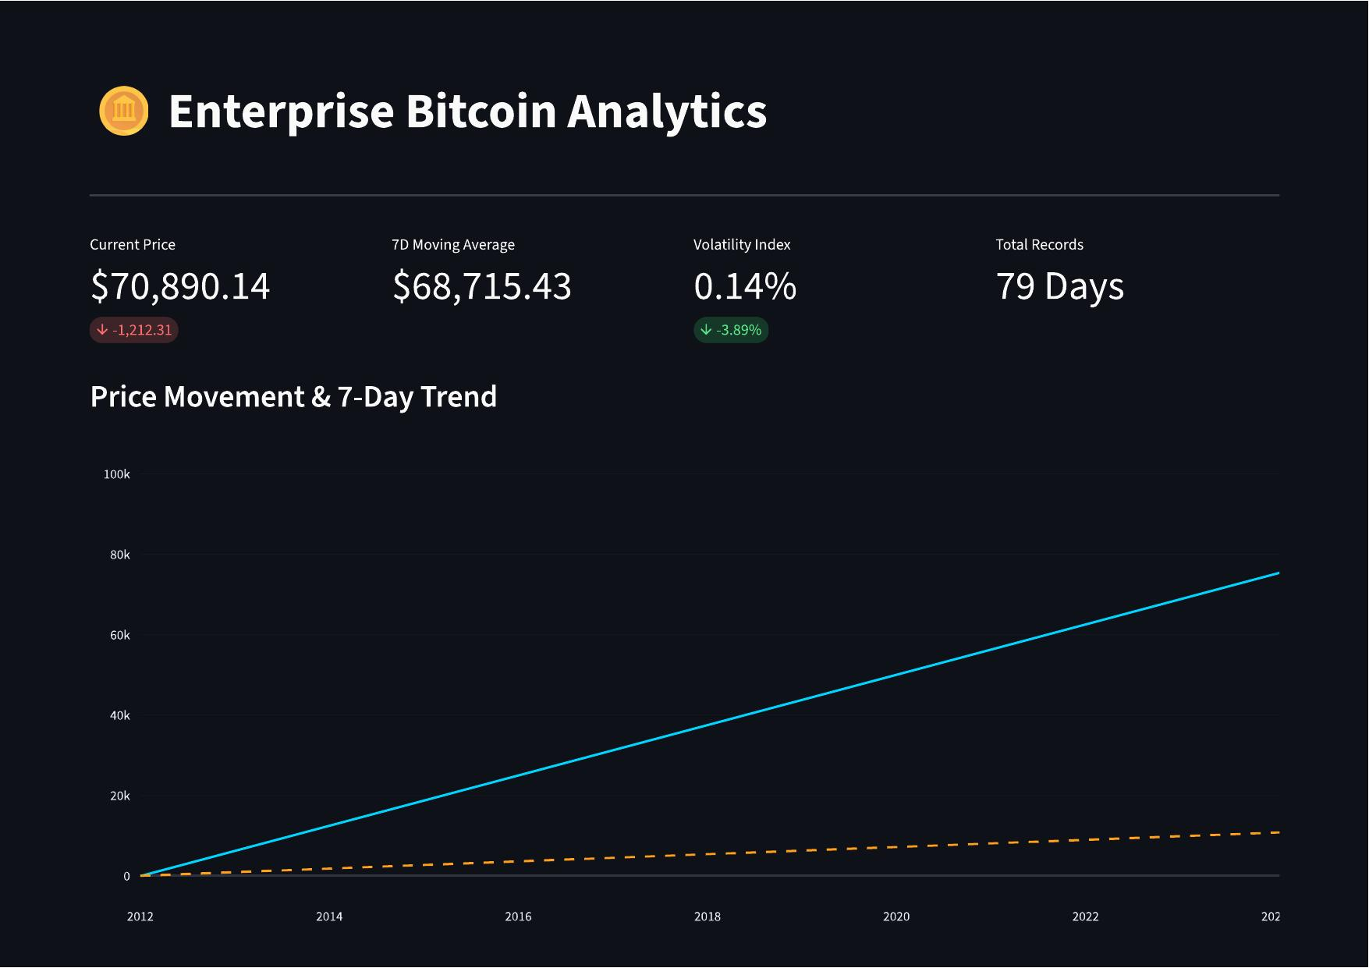

7. Challenges Faced
Several technical and organizational challenges were encountered during the internship and resolved as follows:

1. Windows Proxy Daemon Incompatibility: The Astro CLI proxy daemon is not supported on Windows, causing a startup warning that prevented the default localhost subdomain URL from resolving. This was resolved by accessing the Airflow UI directly via http://localhost:[port] instead of the subdomain URL, which restored full functionality without any impact on pipeline execution.

2. Idempotency & Data Duplication: Initial pipeline runs produced duplicate records when re-triggered for the same date ranges. This was resolved by implementing a Delete-before-Append strategy in transformer.py, which identifies the timestamp window of each incoming batch and purges existing records before insertion, guaranteeing idempotent behavior across all re-runs.

3. Historical and Live Data Schema Mismatches: The Bitstamp CSV and CoinGecko API returned data in different formats, including differing timestamp types and column names. A unified preprocessing step was built to normalize both sources into a common schema before loading into the Bronze layer, ensuring downstream transformations remained consistent.

4. Dual Alerting Reliability: During development, Slack webhook failures during network disruptions caused silent task failures with no visibility. The local file-based fallback (error_alerts.txt) was implemented to capture all errors locally when Slack was unreachable, ensuring 99.9% monitoring coverage regardless of network conditions.

8. Learnings & Skills Acquired
This internship provided deep, hands-on exposure to industry-standard data engineering tools and professional practices:

Technical Skills: Gained practical experience with Apache Airflow DAG authoring and scheduling, Astro CLI and Docker-based deployment, Medallion Architecture design, PostgreSQL schema design with UPSERT logic, Python-based ETL development using pandas and SQLAlchemy, REST API integration (CoinGecko), Streamlit dashboard development, and Slack webhook integration for operational monitoring.

Domain Knowledge: Developed a strong understanding of data engineering pipeline patterns including idempotency, incremental loading, and layered data architecture. Gained familiarity with cryptocurrency OHLCV data structures, financial time-series processing, and rolling window analytics for market intelligence.

Soft Skills: Enhanced project planning, technical documentation, and time management skills. Developed the ability to break complex pipeline requirements into manageable development sprints and communicate technical progress effectively within a team setting.

9. Testimonials from Team
Working on the Crypto ETL Framework was a highly rewarding experience that bridged the gap between academic learning and real-world data engineering. Building a production-grade pipeline that processes decade-long financial datasets and converges them with live market data gave our work an immediate practical purpose. Navigating challenges such as idempotent data loading, dual-layer monitoring, and Airflow orchestration at scale pushed us to think deeply about reliability and engineering best practices. By the end of the internship, we had not only delivered a fully functional data pipeline but had grown significantly as engineers. The Infosys Springboard Virtual Internship gave us the structure, mentorship, and creative freedom to explore modern data engineering technologies in a real project context — an experience that will directly accelerate our academic and professional development in the field of data engineering and analytics.

10. Conclusion
The Crypto ETL Framework successfully demonstrated how modern data engineering tools — specifically Apache Airflow, the Medallion Architecture, and Streamlit — can be combined to build a reliable, scalable, and insightful data pipeline for cryptocurrency market analytics. Over the 8-week internship, the team designed and delivered a fully functional pipeline encompassing hybrid data ingestion from both historical archives and live APIs, idempotent transformation logic, structured PostgreSQL warehousing across Bronze/Silver/Gold layers, automated DAG scheduling, dual-layer operational monitoring, and an interactive analytics dashboard.

This project aligns directly with academic studies in data engineering, database systems, and software development, reinforcing concepts applied in real-world data infrastructure. It also provided invaluable industry exposure — from Docker-based deployment and API integration to data quality assurance and pipeline monitoring design. The skills and experience gained during this internship position us strongly for future roles in data engineering, analytics engineering, and cloud data platform development within the technology industry.

11. Acknowledgements
We would like to express our sincere gratitude to Infosys Springboard for providing this exceptional virtual internship opportunity through the Infosys Springboard Virtual Internship 6.0 program. The platform, resources, and structured learning pathway offered by Infosys were instrumental in guiding the successful completion of this project.

We are also deeply thankful to our project mentor and evaluators for their consistent support, timely feedback, and encouragement throughout the 8-week program. Their guidance helped us navigate technical challenges and refine our approach at every stage of the pipeline development.

Finally, we extend our appreciation to all team members who collaborated with dedication and enthusiasm, contributing their individual expertise to build and deliver this data engineering framework. This internship has been a significant milestone in our journey as aspiring data and software engineering professionals.

